Docker interview question and answers

1️⃣ What is Docker?
Answer:
“Docker is a platform for containerization that allows you to package an application and its dependencies into a lightweight, portable container that can run consistently across different environments.”
Elaboration (if asked):
“It simplifies deployment, scales easily, and isolates applications without the overhead of traditional virtual machines.”

2️⃣ What is a Docker Image?
Answer:
“A Docker image is a read-only template containing the application code, libraries, and dependencies required to create a container. It’s like a blueprint for containers.”
Example:
ubuntu:latest or nginx:alpine.

3️⃣ What is a Docker Container?
Answer:
“A container is a running instance of a Docker image. It’s lightweight, isolated, and includes its own filesystem, processes, and network stack, but shares the host OS kernel.”

4️⃣ Difference Between Container and Virtualization (VMs)
Answer:
Feature | Container | Virtual Machine
OS | Shares host OS | Full OS per VM
Resource | Lightweight | Heavy
Startup | Seconds | Minutes
Isolation | Process-level | Hardware-level
Example | Docker | VMware, VirtualBox
Short Version for Interview:
“Containers share the host OS and are lightweight, while VMs run a full OS and are heavier and slower to start.”

5️⃣ Why We Need Docker
Answer:
- Ensures consistency across environments (dev, test, prod)
- Isolates applications to avoid dependency conflicts
- Lightweight and faster than VMs
- Portable and scalable for microservices
Short Version:
“Docker makes applications portable, consistent, and easy to scale.”

6️⃣ Few Instructions in a Dockerfile
Answer:
- FROM → base image
- RUN → run commands during build
- COPY / ADD → copy files into container
- WORKDIR → set working directory
- CMD → default command to run when container starts
- EXPOSE → expose ports

FROM ubuntu:latest
RUN apt update && apt install -y python3
COPY app.py /app/
WORKDIR /app
CMD ["python3", "app.py"]
EXPOSE 5000

what is host os and hypervisor?
1️⃣ Host OS
- The Host OS is the operating system running directly on physical hardware.
- It manages hardware resources (CPU, memory, storage, network) and provides an environment for applications or virtual machines to run.
- All virtualization or containerization software relies on the host OS to access hardware resources.
Example:
If you install Ubuntu on a laptop and then run Docker or VirtualBox, Ubuntu is the host OS.

2️⃣ Hypervisor
- A hypervisor is software that allows you to run multiple virtual machines (VMs) on a single physical machine.
- It abstracts hardware and allocates CPU, memory, and storage to VMs, providing isolation between them.
Types of Hypervisors:
- Type 1 (Bare Metal): Runs directly on hardware
  - Examples: VMware ESXi, Microsoft Hyper-V, Xen
- Type 2 (Hosted): Runs on top of a Host OS
  - Examples: VirtualBox, VMware Workstation
Example:
If you have Windows as the host OS and run VirtualBox to create Ubuntu and CentOS VMs, VirtualBox is the hypervisor.

3️⃣ Quick Difference
Feature | Host OS | Hypervisor
Role | Manages hardware & software | Manages VMs & allocates resources
Location | Directly on physical hardware | On hardware (Type 1) or Host OS (Type 2)
Example | Ubuntu, Windows, CentOS | VMware ESXi, VirtualBox

- “What is Host OS and Hypervisor?”
You can say:
“Host OS is the OS running on physical hardware, while a hypervisor is software that lets us run multiple VMs on top of it, managing resources and isolation.”

Diagram: Host OS, Hypervisor, and VM

+-------------------------------------------------+
| Virtual Machine 1 (VM1) |
| Guest OS: Ubuntu |
| Applications: Apache, Python, etc. |
+-------------------------------------------------+
| Virtual Machine 2 (VM2) |
| Guest OS: Windows 10 |
| Applications: MS Office, Chrome |
+-------------------------------------------------+
| Hypervisor |
| (Type 1 or Type 2) |
| Manages CPU, Memory, Storage allocation |
+-------------------------------------------------+
| Host OS |
| Windows 11 / Ubuntu / MacOS |
| Manages Hardware: CPU, RAM, Storage, Network|
+-------------------------------------------------+
| Physical Hardware |
| CPU, RAM, Disk, Network, GPU |
+-------------------------------------------------+

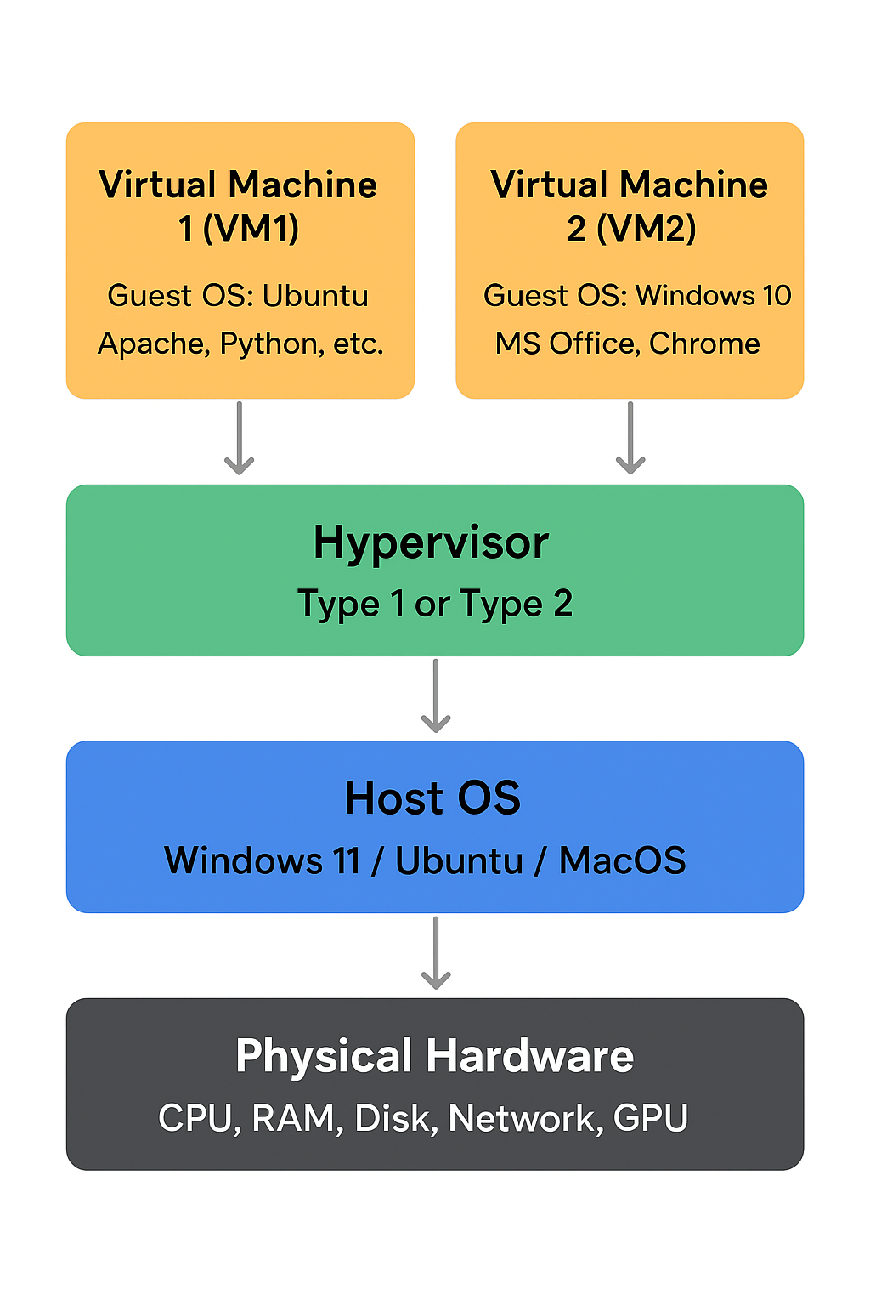

Layer-by-Layer Explanation
- Physical Hardware
  - This is the actual machine: CPU, RAM, Disk, GPU, Network.
  - Everything runs on top of this.
  - Analogy: The foundation of the house.
- Host OS
  - Installed directly on hardware.
  - Manages resources and provides an environment for applications.
  - If you’re using a Type 2 hypervisor, it sits on top of this OS.
  - Analogy: House manager who controls electricity, water, and rooms.
- Hypervisor
  - Software that creates and manages virtual machines.
  - Divides physical resources into slices for each VM.
  - Type 1: Directly on hardware (no Host OS needed).
  - Type 2: Runs on Host OS.
  - Analogy: Room partitioner who divides the house into independent rooms.
- Virtual Machines (VMs)
  - Each VM is like a mini-computer with its Guest OS and apps.
  - VMs are isolated; a crash in one doesn’t affect the others.
  - Analogy: A room where a family lives, with its own furniture and rules.
- Guest OS
  - OS installed inside a VM.
  - Thinks it’s running on its own hardware, but uses virtualized hardware.
  - Example: Ubuntu, Windows 10, CentOS inside different VMs.

Visual Example in Real Life
- Host OS: Your Windows 11 laptop.
- Hypervisor: VirtualBox installed on Windows.
- VM1 Guest OS: Ubuntu running inside VirtualBox.
- VM2 Guest OS: Windows 10 running inside VirtualBox.
- Applications: You can run Chrome in VM2 and Python scripts in VM1 at the same time without conflicts.

docker --version
# Example: docker --version
# Output: Docker version 25.0.2, build abc123

docker info
# Example: docker info
# Shows system info, running containers, storage, etc.

docker images
# Example: docker images
# Lists all Docker images on your machine

docker pull ubuntu:latest
# Example: docker pull ubuntu:latest
# Downloads the latest Ubuntu image from Docker Hub

docker build -t my_app:1.0 .
# Example: docker build -t my_app:1.0 .
# Builds Docker image from current directory Dockerfile

docker rmi my_app:1.0
# Example: docker rmi my_app:1.0
# Removes a Docker image

docker run -it ubuntu:latest
# Example: docker run -it ubuntu:latest
# Runs a container interactively from Ubuntu image

docker ps
# Example: docker ps
# Lists all running containers

docker ps -a
# Example: docker ps -a
# Lists all containers (running + stopped)

docker stop my_container
# Example: docker stop my_container
# Stops a running container

docker start -ai my_container
# Example: docker start -ai my_container
# Starts a stopped container and attaches terminal

docker exec -it my_container bash
# Example: docker exec -it my_container bash
# Opens shell inside running container

docker rm my_container
# Example: docker rm my_container
# Deletes a stopped container

docker volume create my_vol
# Example: docker volume create my_vol
# Creates a Docker volume named my_vol

docker network create my_net
# Example: docker network create my_net
# Creates a Docker network

docker system prune -a
# Example: docker system prune -a
# Removes all unused containers, networks, images

